Lim, Francis Raemark L. 12/4/2019

2ECE-C

**Problem 1:**

Given four data frames

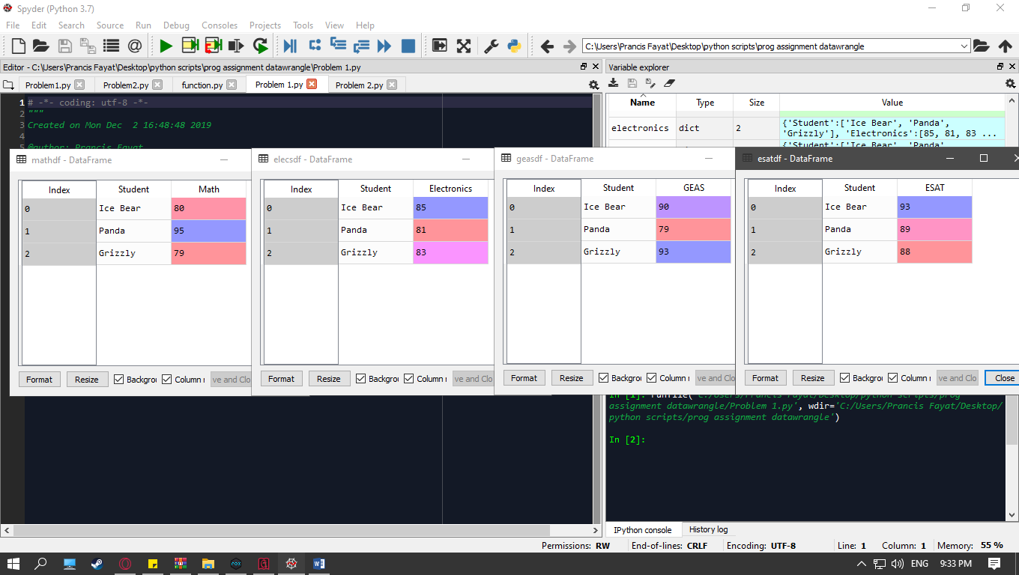

Merged dataframe using pd.merge

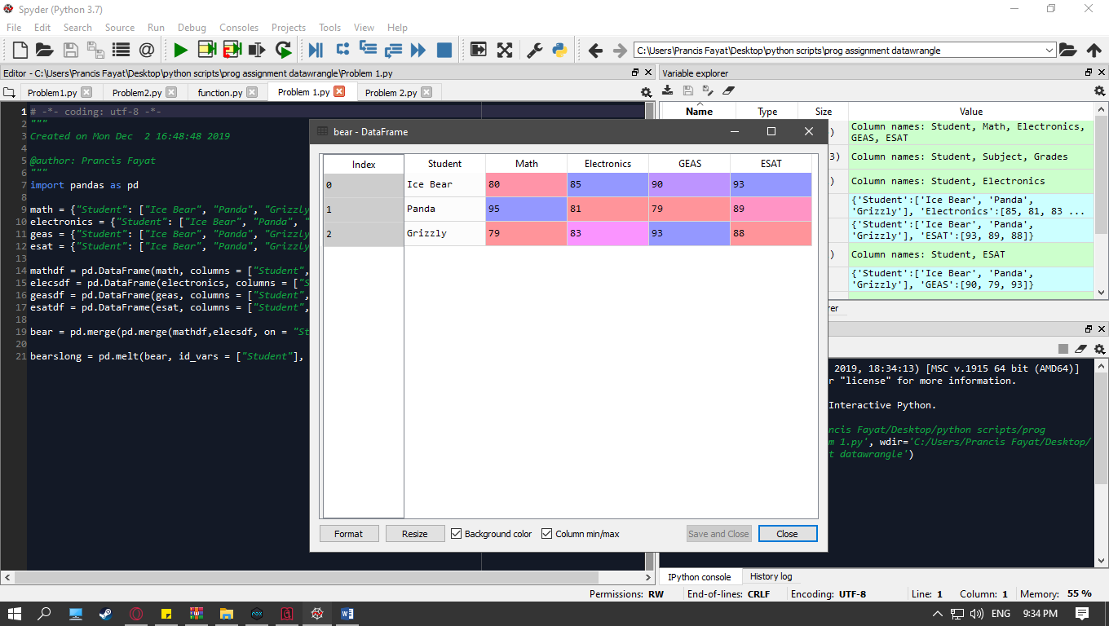

Merged data frame converted into long format (using pd.melt())

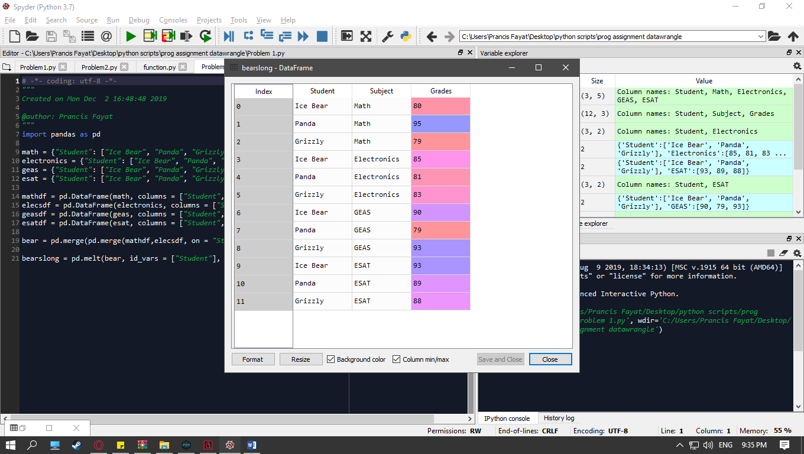

**Problem 2:**

Initial dataframe

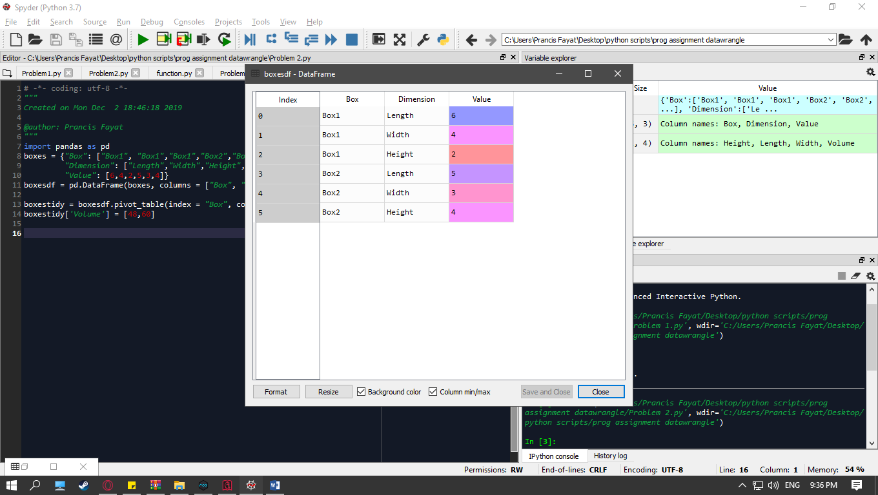

Messy data frame transformed into tidy dataframe using pd.pivot_table()  
note: boxestidy[‘Volume’] = boxestidy.Length * boxestidy.Width * boxestidy.Height was removed to display the tidy dataframe without the added “Volume” column.

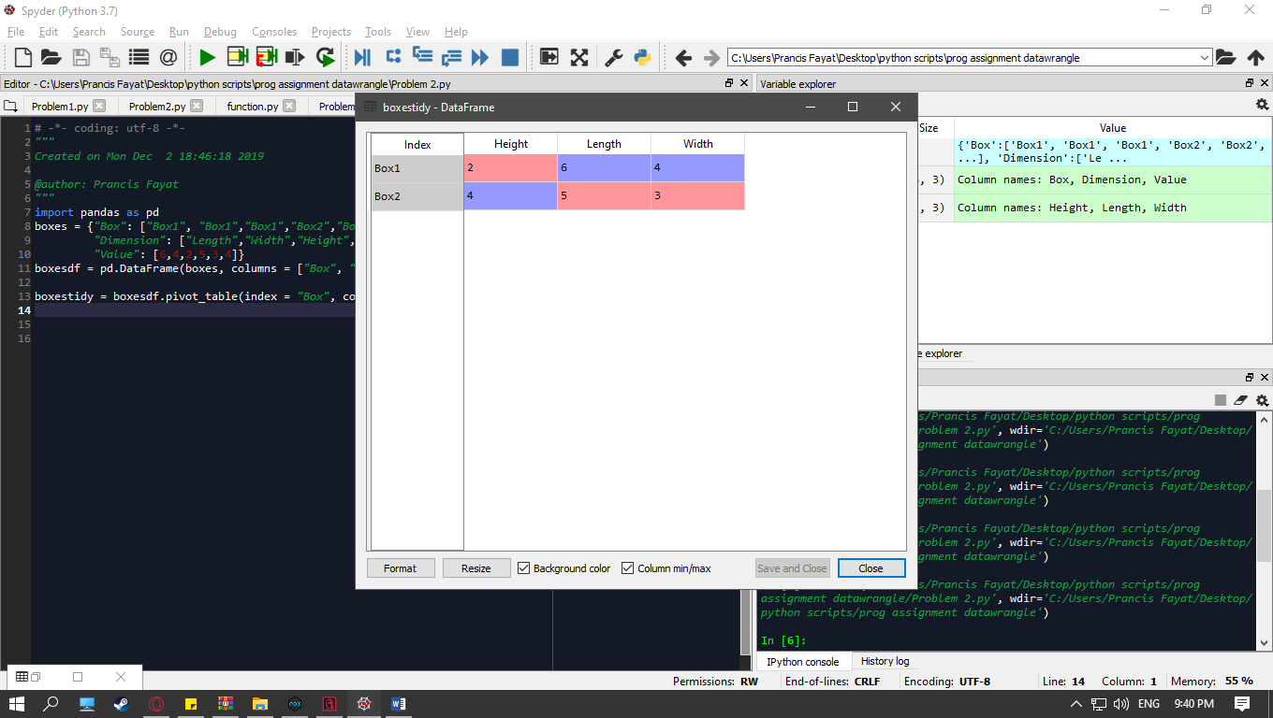

Tidy data frame with an added column named “Volume” that contains the volume of each box.

boxestidy[‘Volume’] = boxestidy.Length * boxestidy.Width * boxestidy.Height

